Data Driven Business Decisions Made Easy with Data Virtualization and Business Rules Management System

We have created a integrated demo project to get you started with automatically installing two EAP instances, one with JBoss BRMS product and the other with JBoss DV product configured and installed. There will be various example projects the demonstrate some of the available scenarios around working with the capabilities of these two product. Our first example is focused on a Customer Service Use Case.
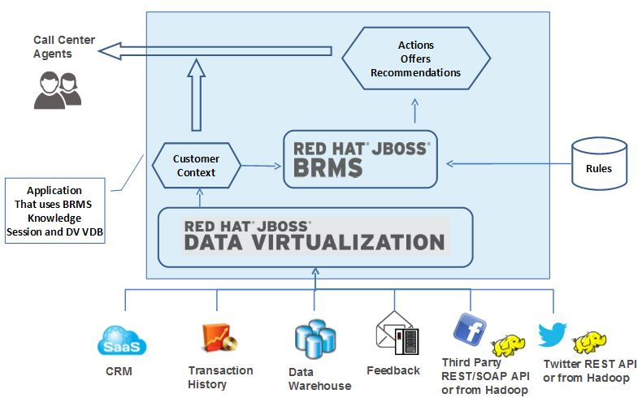

Overview of Demonstration

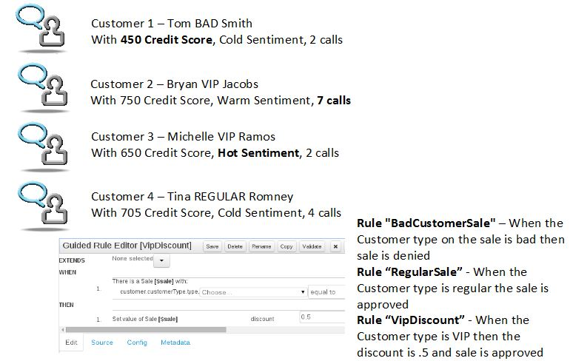
Use Case 1
Objective: Determine what offers or discounts can be offered to the customer according to the customer context
Problem: Call center agents don't have easy access to all the data and the business rules are manual
Solution: Use DV to create a unified view for a customer context which can then be applied to business rules in BRMS to automatically determine the offers or discounts for the customer
We are combining 2 quickstarts from DV and BRMS. We have a Customer flat file and a Customer History XML File. We combine those into a single unified view in the Virtual Database (VDB). We use the Teiid JDBC Driver to be able to access the VDB that is deployed to the DV Server. We read the data and decide what type of customer they are according to their credit score, sentiment and customer calls. This helps setup the Customer Context. From this the BRMS rules determine if the sale will be a Bad Customer Sale, a Regular Sale, and VIP Discount. The demonstration is easy to run.

Technical Details of Demonstration

Data Virtualization

In JBoss Developer Studio with the Integration Stack loaded, we perform two action sets. This is similar to the document, https://developer.jboss.org/docs/DOC-18404, that describes Federating multiple datasources. We create the local XML and Flat file connections, then create the source models and the Unified View. You will end up with a Teiid Project similar to the below. Notice the CustomerContext View and the transformation. You can pull the project into JBDS to work more with the project. The project is located in github at https://github.com/kpeeples/dv-brms-integration-demo/tree/master/projects/dvworkspace/dvbrms.
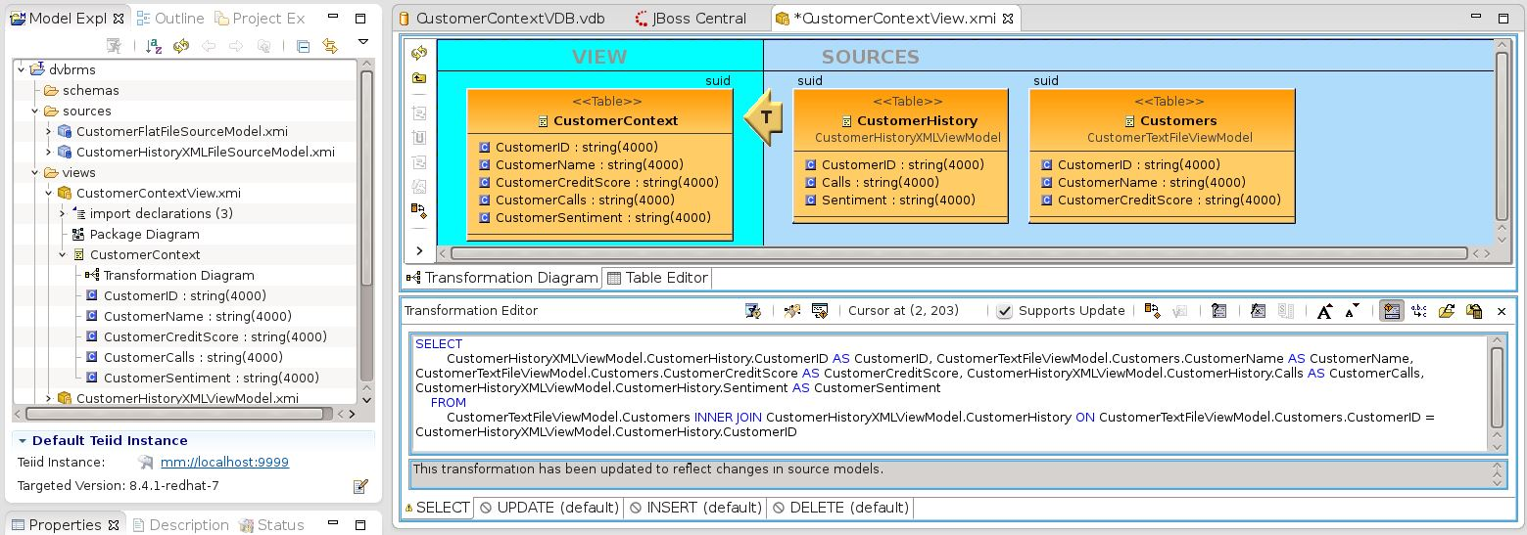
When running the init script the VDB is deployed along with the data. First the Data Virtualization server is installed. The teiid security files are then moved over to the server which sets up the user that we will use to connect with to the VDB.
Teiid-security-roles.properties
# A roles.properties file for use with the UsersRolesLoginModule
# username=role1,role2
user=admin,odata,example-role
# Dashboard builder roles
# edit mode: admin
# read only: user

Teiid-security-roles.properties
# A users.properties file for use with the UsersRolesLoginModule
# username=password
user=user

Next the data files are moved over to the data directory for the DV standalone server. The Customer.txt and CustomerHistory.xml are setup as datasources in the standalone.xml for the VDB to use. Then the Virtual Database files, CustomerContextVDB.vdb and CustomerContextVDB.vdb.dodeploy, are moved to the DV deployment folder. Lastly the standalone.xml is moved over to the DV standalone configuration folder to configure the datasources. Notice the directory to the location off the files are set.

<resource-adapter id="CustomerFlatFileSourceModel">
<module slot="main" id="org.jboss.teiid.resource-adapter.file"/>
<transaction-support>NoTransaction</transaction-support>
<connection-definitions>
<connection-definition class-name="org.teiid.resource.adapter.file.FileManagedConnectionFactory" jndi-name="java:/CustomerFlatFileSourceModel" enabled="true" pool-name="CustomerFlatFileSourceModel">
<config-property name="ParentDirectory">
${jboss.home.dir}/standalone/data/
</config-property>
</connection-definition>
</connection-definitions>
</resource-adapter>
<resource-adapter id="CustomerHistoryXMLFileSourceModel">
<module slot="main" id="org.jboss.teiid.resource-adapter.file"/>
<transaction-support>NoTransaction</transaction-support>
<connection-definitions>
<connection-definition class-name="org.teiid.resource.adapter.file.FileManagedConnectionFactory" jndi-name="java:/CustomerHistoryXMLFileSourceModel" enabled="true" pool-name="CustomerHistoryXMLFileSourceModel">
<config-property name="ParentDirectory">
${jboss.home.dir}/standalone/data/
</config-property>
</connection-definition>
</connection-definitions>
</resource-adapter>

Business Rules Management System

We used the helloworld-brms quickstart which is available from the CSP and it is also out on github at https://github.com/jboss-developer/jboss-brms-quickstarts/tree/6.1.x-develop/helloworld-brms. We add the DV code to the unit test to grab the data first. The BRMS Repository is imported and then the BRMS kmodule is deployed. The HelloWorldBRMSTest.java is shown below with the code added for the DV access. Notice the Teiid JDBC driver is used to access the VDB and retrieve the data from the unified view.
System.out.println("== Using DV to pull federated data then execute rules ==============");
String url = "jdbc:teiid:CustomerContextVDB@mm://localhost:31000";
String sql = "select CustomerID, CustomerName, CustomerCreditScore, CustomerSentiment, CustomerCalls from CustomerContext";
Connection connection = null;
try {
Class.forName("org.teiid.jdbc.TeiidDriver");
connection=DriverManager.getConnection(url,"user","user");
Statement statement = connection.createStatement();
ResultSet results=statement.executeQuery(sql);
int i=0;
CustomerType ctype = new CustomerType();
Customer customer = new Customer();
Sale sale = new Sale();
String type = "regular";
String customerid, customername,customercreditscore,customersentiment,customercalls = "";
while (results.next()) {
customerid=results.getString(1);
customername=results.getString(2);
customercreditscore=results.getString(3);
customersentiment=results.getString(4);
customercalls=results.getString(5);
System.out.println("Customer "+(++i)+" "+customerid+" "+customername+" "+customercreditscore+" "+customersentiment+" "+customercalls);
type = "regular";
//these rules could be moved to BRMS
if (customersentiment.equals("Hot")) type = "VIP";
if (Integer.parseInt(customercreditscore) < 500) type = "BAD";
if (Integer.parseInt(customercalls) > 5) type = "VIP";
//end of the customer definition rules of regular, VIP, BAD
ctype.setType(type);
customer.setCustomerType(ctype);
sale.setCustomer(customer);
System.out.println("** Testing Customer "+i+" **");
kSession.execute(sale);

}
results.close();
statement.close();
System.out.println("=========================================================================");
}
catch (SQLException e) {
e.printStackTrace();
}

catch (Exception e2) {
e2.printStackTrace();
}
finally {
try {
connection.close();
} catch (SQLException el) {
el.printStackTrace();
} catch (Exception e3) {
e3.printStackTrace();
}
}
System.out.println("== Now running original quickstart ==============");
CustomerType regular = new CustomerType();
regular.setType("regular");

Also you can view the deployed kmodule with the defined rule set.
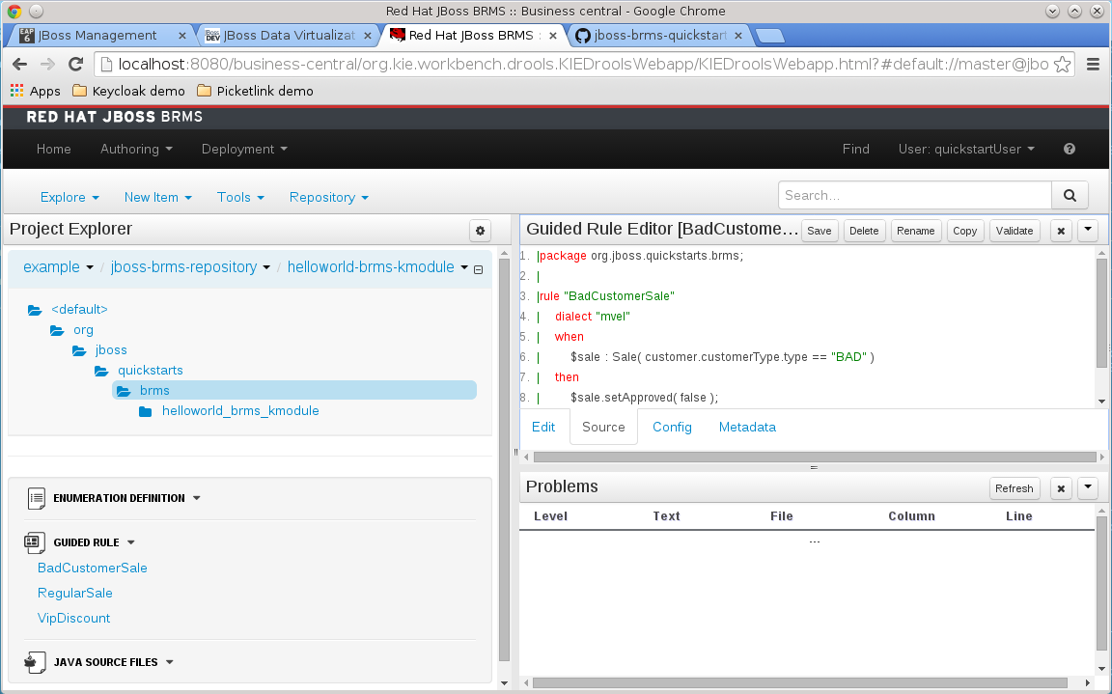

How to Run Demonstration

Step 1: Download and unzip archive from Github at https://github.com/kpeeples/dv-brms-integration-demo/archive/master.zip
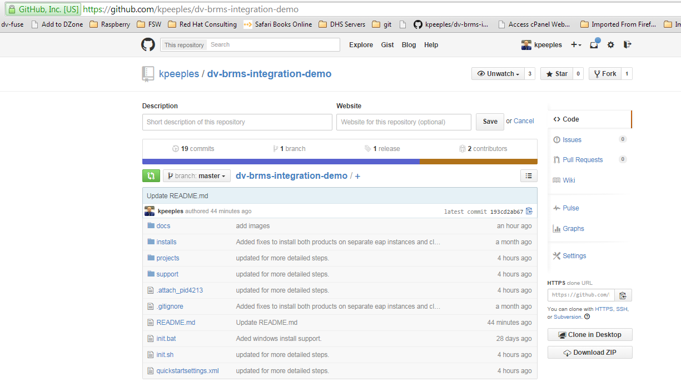
Step 2: Download Data Virtualization and BRMS from JBoss.org and put into installs directory
JBoss Data Virtualization: http://www.jboss.org/products/datavirt/download/
JBoss Business Rules Management System: http://www.jboss.org/products/brms/download/
Step 3: Run init.sh
Step 4: Start the BRMS Server
$ ./target/jboss-eap-6.1/bin/standalone.sh -Djboss.socket.binding.port-offset=100

Step 5: Start the DV Server
$ ./target/jboss-eap-6.1.dv/bin/standalone.sh

Step 6: Login to business central to build & deploy BRMS rules project at http://localhost:8180/business-central with username quickstartUser with password quickstartUser1!. First, Import the BRMS Repository and Second, Deploy the BRMS kmodule
- Choose menu option `Authoring` -> `Administration`
- Choose sub-menu option `Repositories` -> `Clone repository`
- Complete the form as follows:
Repository Name: jboss-brms-repository
Organizational Unit: example (Make sure the organization is created)
Git URL: https://github.com/jboss-developer/jboss-brms-repository.git
User Name: <leave blank>
Password: <leave blank>
- Click the `Clone` button to create the repository. You see the message "The repository is cloned successfully".
- Choose menu option `Authoring` -> `Project Authoring`
- Choose the following options under `Project Explorer`:
Organizational Unit: example
Repository Name: jboss-brms-repository
BRMS Kmodule: helloworld-brms-kmodule
- Next, click on `Tools` and `Project Editor`
- In the tab on the right, click on `Build & Deploy`.
* It will prompt you with a message: "Also save possible changes to project?". Click `Yes`.
* You are prompted for a comment. Add a comment and click on `Save` button.
- This deploys the `org.jboss.quickstarts.brms:helloworld-brms-kmodule:1.0.0` artifact to the BRMS Maven repository. You can verify the deployment choosing menu option `Deployment` --> `Artifact Repository`.

Step 7: Run the Unit Test. The application project simulated as a unit test in projects/brmsquickstart/helloworld-brms which you can run with the maven command below. The test should run successfully. `
$ mvn clean test -f projects/brmsquickstart/helloworld-brms/pom.xml -s quickstartsettings.xml -Penable-test,brms

[kpeeples@localhost dv-brms-integration-demo]$ mvn clean test -f projects/brmsquickstart/helloworld-brms/pom.xml -s quickstartsettings.xml -Penable-test,brms
[INFO] Scanning for projects...
[INFO]
[INFO] ------------------------------------------------------------------------
[INFO] Building JBoss BRMS Quickstart: helloworld-brms 6.0.2.GA-redhat-5
[INFO] ------------------------------------------------------------------------
[WARNING] The POM for org.jboss.teiid:teiid-common-core:jar:8.4.1-redhat-6 is missing, no dependency information available
[INFO]
[INFO] --- maven-clean-plugin:2.5:clean (default-clean) @ brms-helloworld-brms ---
[INFO] Deleting /home/kpeeples/repositories-git/kpeeples/dv-brms-integration-demo/projects/brmsquickstart/helloworld-brms/target
[INFO]
[INFO] --- maven-resources-plugin:2.6:resources (default-resources) @ brms-helloworld-brms ---
[INFO] Using 'UTF-8' encoding to copy filtered resources.
[INFO] skip non existing resourceDirectory /home/kpeeples/repositories-git/kpeeples/dv-brms-integration-demo/projects/brmsquickstart/helloworld-brms/src/main/resources
[INFO]
[INFO] --- maven-compiler-plugin:2.5.1:compile (default-compile) @ brms-helloworld-brms ---
[INFO] No sources to compile
[INFO]
[INFO] --- maven-resources-plugin:2.6:testResources (default-testResources) @ brms-helloworld-brms ---
[INFO] Using 'UTF-8' encoding to copy filtered resources.
[INFO] skip non existing resourceDirectory /home/kpeeples/repositories-git/kpeeples/dv-brms-integration-demo/projects/brmsquickstart/helloworld-brms/src/test/resources
[INFO]
[INFO] --- maven-compiler-plugin:2.5.1:testCompile (default-testCompile) @ brms-helloworld-brms ---
[INFO] Compiling 1 source file to /home/kpeeples/repositories-git/kpeeples/dv-brms-integration-demo/projects/brmsquickstart/helloworld-brms/target/test-classes
[INFO]
[INFO] --- maven-surefire-plugin:2.12.4:test (default-test) @ brms-helloworld-brms ---
[INFO] Surefire report directory: /home/kpeeples/repositories-git/kpeeples/dv-brms-integration-demo/projects/brmsquickstart/helloworld-brms/target/surefire-reports

-------------------------------------------------------
T E S T S
-------------------------------------------------------
Running org.jboss.quickstarts.brms.HelloWorldBRMSTest
17:14:41.766 [main] INFO o.d.c.k.b.impl.ClasspathKieProject - Found kmodule: jar:file:/home/kpeeples/.m2/repository/org/jboss/quickstarts/brms/helloworld-brms-kmodule/1.0.0/helloworld-brms-kmodule-1.0.0.jar!/META-INF/kmodule.xml
17:14:41.787 [main] DEBUG o.d.c.k.b.impl.ClasspathKieProject - KieModule URL type=jar url=/home/kpeeples/.m2/repository/org/jboss/quickstarts/brms/helloworld-brms-kmodule/1.0.0/helloworld-brms-kmodule-1.0.0.jar
17:14:42.062 [main] DEBUG o.d.c.k.b.impl.ClasspathKieProject - Found and used pom.properties META-INF/maven/org.jboss.quickstarts.brms/helloworld-brms-kmodule/pom.properties
17:14:42.070 [main] DEBUG o.d.c.k.b.impl.ClasspathKieProject - Discovered classpath module org.jboss.quickstarts.brms:helloworld-brms-kmodule:1.0.0
17:14:42.076 [main] INFO o.d.c.k.b.impl.KieRepositoryImpl - KieModule was added:ZipKieModule[ ReleaseId=org.jboss.quickstarts.brms:helloworld-brms-kmodule:1.0.0file=/home/kpeeples/.m2/repository/org/jboss/quickstarts/brms/helloworld-brms-kmodule/1.0.0/helloworld-brms-kmodule-1.0.0.jar]
17:14:43.405 [main] DEBUG o.drools.core.reteoo.ReteooRuleBase - Starting Engine in PHREAK mode
== Using DV to pull federated data then execute rules ==============
Customer 1 123 Tom BAD Smith 450 Cold 2
** Testing Customer 1 **
Bad customer. Sale denied
Customer 2 456 Bryan VIP Jacobs 750 Warm 7
** Testing Customer 2 **
VIP discount applied
Sale approved
Customer 3 789 Michelle VIP Ramos 650 Hot 2
** Testing Customer 3 **
VIP discount applied
Sale approved
Customer 4 654 Tina REGULAR Romney 705 Cold 4
** Testing Customer 4 **
Sale approved
=========================================================================
== Now running original quickstart ==============
** Testing VIP customer **
VIP discount applied
Sale approved
** Testing regular customer **
Sale approved
** Testing BAD customer **
Bad customer. Sale denied
Tests run: 3, Failures: 0, Errors: 0, Skipped: 0, Time elapsed: 4.311 sec

Results :

Tests run: 3, Failures: 0, Errors: 0, Skipped: 0

[INFO] ------------------------------------------------------------------------
[INFO] BUILD SUCCESS
[INFO] ------------------------------------------------------------------------
[INFO] Total time: 10.962s
[INFO] Finished at: Sun Sep 21 17:14:45 EDT 2014
[INFO] Final Memory: 24M/302M
[INFO] ------------------------------------------------------------------------

